**SAMPLE RESULTS:**

Content Image

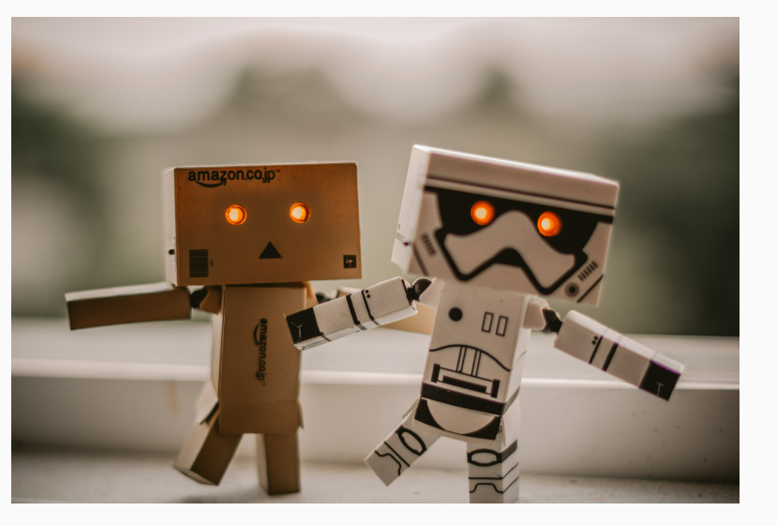

Style Image 1 :

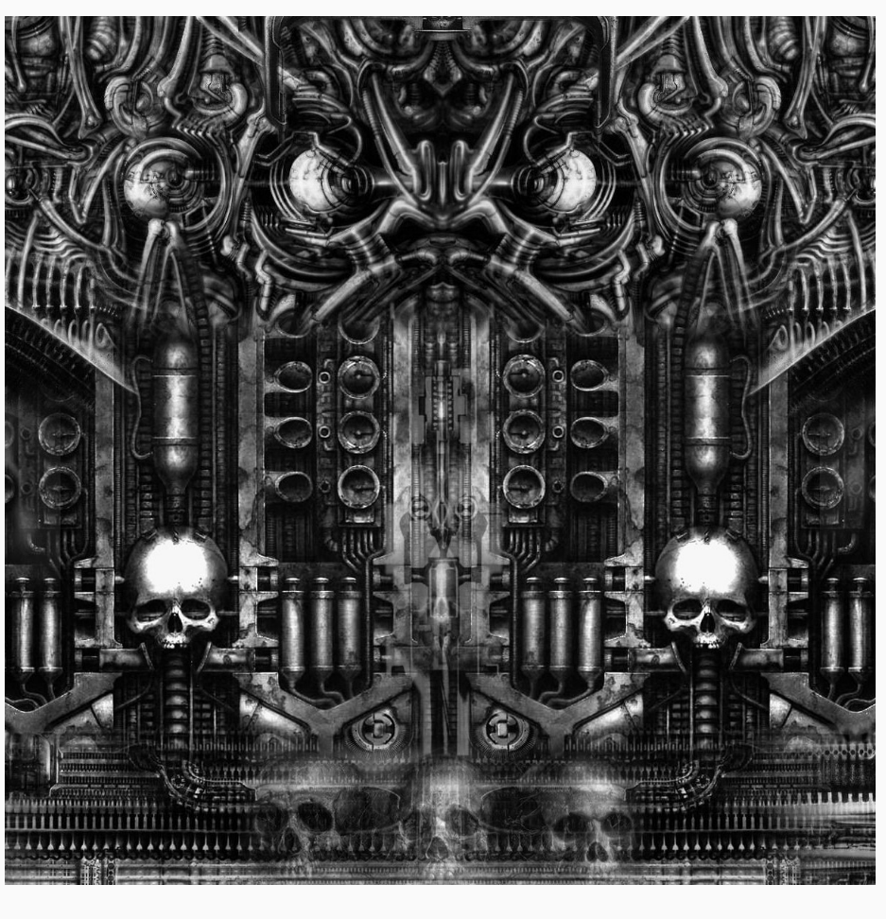

Style Image 2 : (Mosaic)

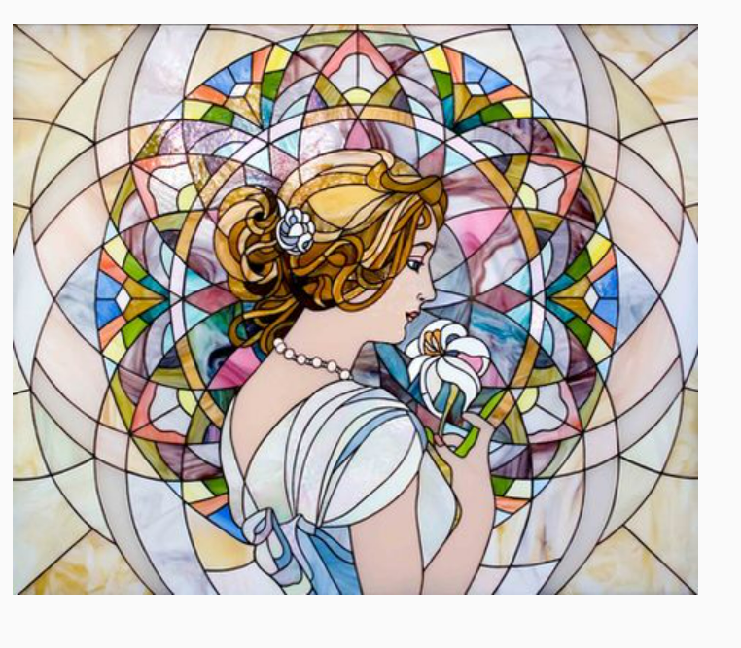

Multi-objective output :

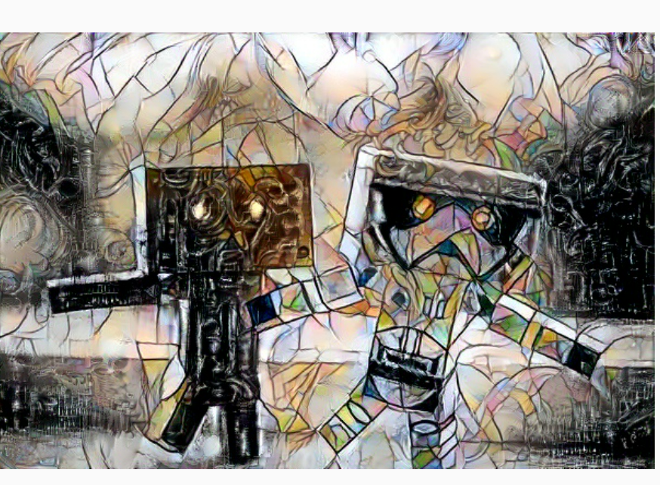

Cascaded Output (Plain) :

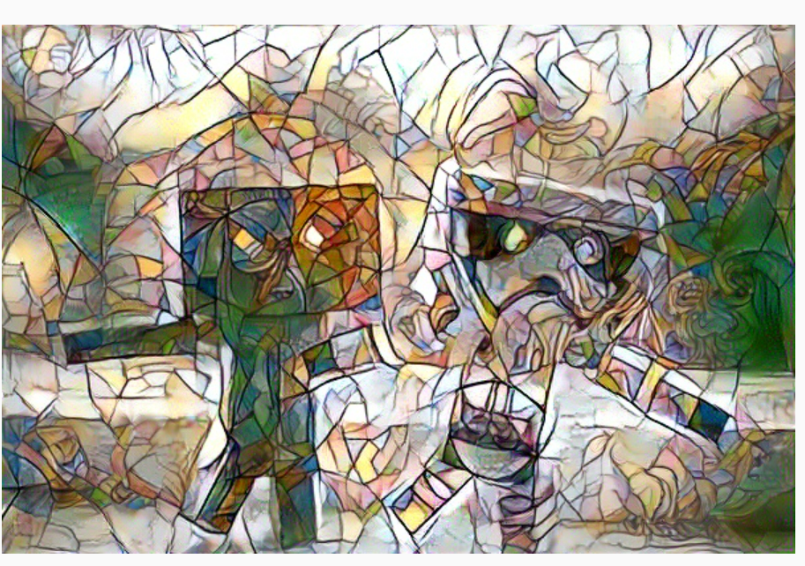

Cascaded Output (Weighted) :

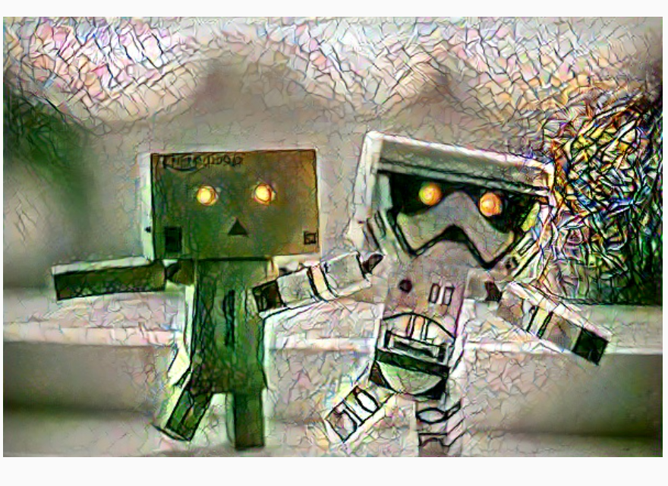

Varying Different Parameters :

Increasing effect of style 2

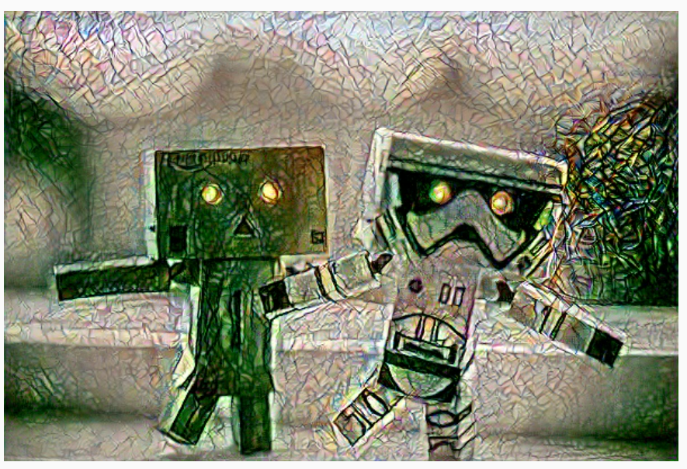

**TRANSFORMER NETWORK RESULTS : Cascade Style Transfer**

Content Image



Style Image 1 :

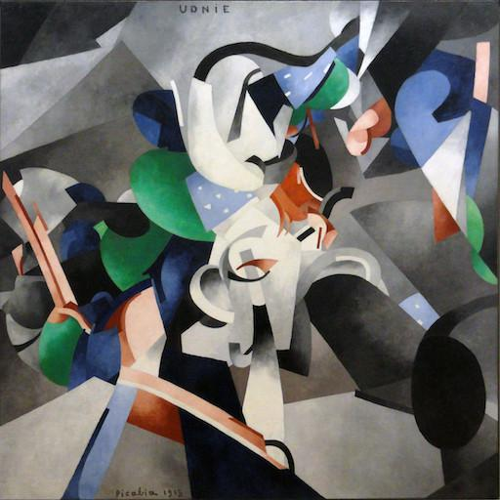

Style Image 2 : (Mosaic)



Style 1 : Udnie

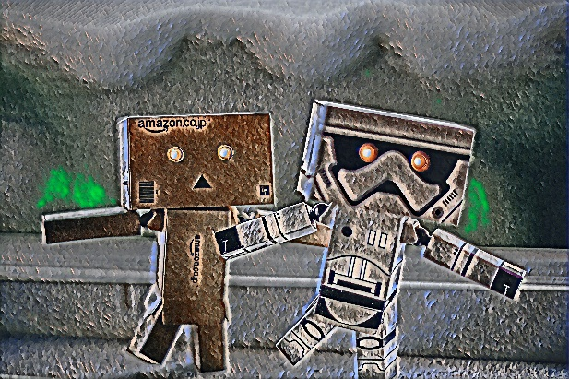

Style 2: Mosaic  
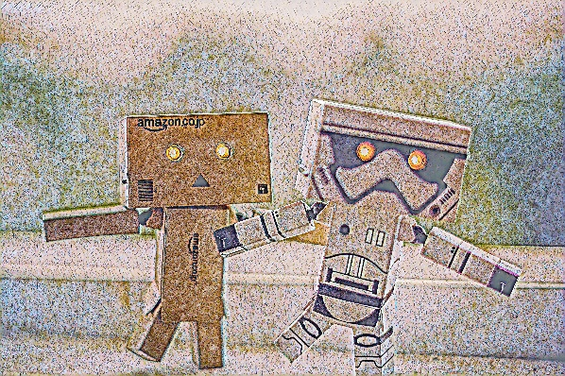

Style 1 + Style 2 = Udnie then Mosaic

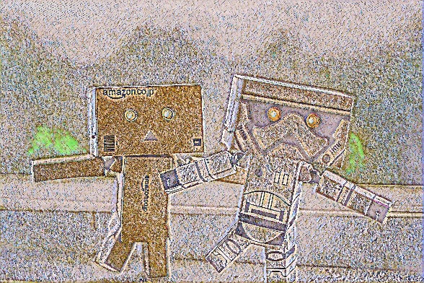

Style 2 + Style 1 = Mosaic then Udnie

